2023 Newsletter of
The Marion County Beekeepers Association
FOUNDED 1971

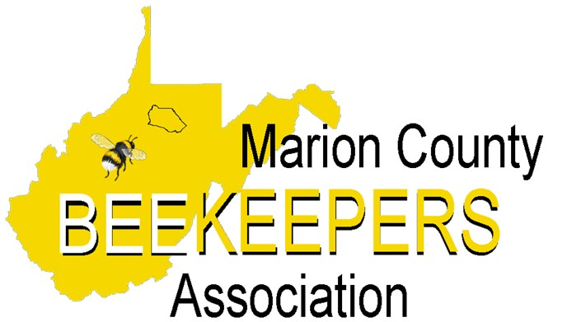

Check out our user-friendly website: mcbawv.com Visit us on Facebook at Marion County Beekeepers
Message From the President
Well, we have had a few warm days in this new year. A good time to see your bees making cleansing flights. That's a good sign they've made it this far. Sugar on inner cover absorbs moisture and feeds them too.
Look forward to seeing you all at our January meeting. Time to get your equipment ready, spring is coming.
Charlie Chipps
MCBA President

2023 MARION COUNTY BEEKEEPERS ASSOCIATION OFFICERS
President
Charlie Chipps (304) 612-5478 (cwchipps@msn.com)
Vice President
Louisa Householder (304) 844-0236 (theweezie@msn.com)
Secretary

Treasurer
Amy Kaiser (304) 368-0609 (ottoamy105@yahoo.com)
Chaplain
Otto Kaiser (304) 368-0609 (ottoamy105@yahoo.com
Webmaster
Dana Gray (304) 694-1968 (wvabeek@gmail.com)
Newsletter Editor
Nancy Postlethwait (304) 366-9938 (lpostlethwait@aol.com)
Board of Directors
Chuck Cienawski (304) 534-3196 (ccienawski1017@aol.com)
Bill Daetwyler (304) 641-6218
Tyler Poling (304) 677-5333 (tylerpoling2011@gmail.com)

MCBA Committees
Phone. Contact Amy Kaiser if you have a change of phone number or email address.

Library. Andy Holcomb
All types of media are available at monthly meetings.

WVBA Executive Board: Louisa Householder, President; Chuck Cienawski is the Marion Co. Representative; Otto Kaiser, Alternate; Aretha Kees, WVBA photographer and historian; Nancy Postlethwait, Budget and Finance Chairwoman.

WVDA State Apiarist: Shanda King (304-840-3236) sking@wvda.us

Association of the Year - Marion County has won this award many times due to our participation in activities and education events. If you give public presentations, be sure to report it.
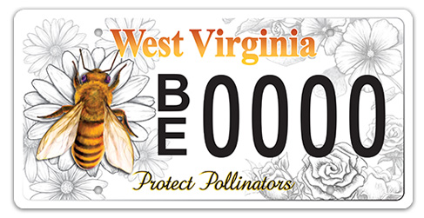The WV DMV has issued a license plate to promote pollinator awareness. It is now available at local DMV offices or online at https://transportation.wv.gov/DMV/DMVFormSearch/DMV-46-TR-wf.pdf

Judy Wilhelm Youth Scholarship - MCBA offers the Judy Wilhelm Youth Beekeeping Scholarship. Marion and Taylor County students between 12 and 17 are invited to apply for the award. Successful recipient will receive training and equipment with a value of over $400. Our goal is to educate our youth in the skill of beekeeping and encourage a better understanding of the value of the honeybee to our environmental and to the food chain. Information and the application can be found on mcbawv.com.

Beginner Beekeeping School will be held on February 2, 7, 9, 14, 16 and the 21st at 6:00 pm. The cost will be $50. Registration forms are available online at mcbawv.c.om and can be paid through PayPal. Contact Nancy at 304-612-9699 for information and preregistration.
Registration Fee includes (non-refundable):
~Textbook and all class materials
~2023 Membership in both MCBA and WVBA
~Newsletters from both organizations
~Discount on American Bee Journal Magazine
~Free registration to WVBA Conference Fall 2023

West Virginia Beekeepers Association News (wvbeekeepers.org)
MCBA is an affiliated club of the WV Beekeepers Association. When you pay your $15 club dues, a portion of those dues ($6) pays for your membership to the state association.
WVBA is offering two conferences in 2023 that are right here in Harrison and Marion counties March 17-18 and October 20-21. If you have never attended a conference before, you won't want to miss this year. Conferences are full of education opportunities, bee chat, and bee supplies right here in our backyard.
Library- Available to all MCBA members as a resource of information is the club library. MCBA has worked hard to expand the number of resources available to our club members and have approximately 70 different items that range from various Beekeeping Books to informative Beekeeping DVDs. A complete list of all materials available is on the mcbawv.com website, just click on the Library link. Resources have typically been available at each in-person meeting. A list of these resources can be found on the Marion County Beekeepers Association Facebook page under the files folder.

Hive Registration - WV beekeepers are required to register their hives with the WV Department of Agriculture within 10 days of the date that they are acquired. WV Code 19-13-4 states that “All apiary certificates of registration expire on June 30 of each year and must be renewed annually.” Just go to wvbeekeepers.org and then click on documents. Then go down to the section that reads WV Immunity Law and Honeybee Best Practices and click on the shield below that to find the Immunity Law and Best Practices.

Extracting Equipment for Rent—MCBA has extracting equipment for rent, including uncapping knife and tank. The cost is $25 deposit with a $15 refund when returned clean, within a 5-day period. A late fee may occur if returned late. Contact any officer or board member.

WV Market Bulletin - has a special section “Apiary Sales” for beekeepers. If you don’t already get the WV Market Bulletin, you may request it by writing to: The Market Bulletin, WV Dept. of Agriculture, 1900 Kanawha Blvd., E., Charleston, WV 25305, OR you may receive it through email by contacting: marketbulletin@ag.state.wv.us

“Telling the Bees” – Obituaries

Wilma Lee Schmuck, 76, passed away May 19, 2022. She and her husband, James were members of the 2018 Bee School.

Frank F. Wilhelm, 81, passed away October 1, 2022, at the home of relatives, Rodney and Mary Nieman. Frank and his wife Judy, who preceded him in death in October 2015, were devoted members of the Preston and Marion County Beekeepers Associations as well as the WV Beekeepers Association. Frank and Judy were voted WV Beekeeper of the Year 2014, an award they shared with Maxine and Charles Walter. One of Frank’s favorite activities was presenting the wonder of honeybees to others, particularly local grade school children and 4-H groups. Frank became interested in beekeeping through Judy’s Uncle, Herb Shafer. Herb and Frank worked together as a team for many years. – Submitted by Tom & Aretha Kees

Gerhard “Gary” Miller, 95, passed away December 18, 2022. He and his wife, Julie Kabulski were active members until her passing in 2013.
***** MCBA 2023 Program Schedule ****

January 26th, Thursday 6-8 PM Annual dues collection at 6:00. Please fill out and bring the enclosed registration form.
Eldora United Methodist Church At 7:00 information on nucs, packages, and queens and Late Winter Feeding.

February 2 to 21. 6-8 PM Beginning Beekeepers Short Course– More information available on website

Marion County Visitors Center mcbawv.com and Marion County Beekeepers – Fairmont Facebook page

Feb. 23 - Thursday, 7-9 PM Field Watch – A new WVDA Program Shanda King
Eldora United Methodist Church WV State Apiarist

March 17th & 18th Spring Conference Hosted by Mountaineer Beekeepers
Village Square Conf Center-Clarksburg Go to mountaineerbeekeepers.com or wvbeekeepers.org for more info

March 23 - Thursday, 7-9 PM Management for a Purpose Charlie Chipps
Eldora United Methodist Church Making Splits for Increased Population

April 27 - Thursday, 7-9 PM Varroa Management: Mark Lilly
Eldora United Methodist Church The Importance of Treatment Timing Appalachian Beekeeping Collective

May 20 – Sat., 10-2 Field Day – Looking into the Hive Gerrie DeGroot
Louisa Householder Bee Yard Doors Prizes Make-and-Take Gadgets

June 22 – Thursday, 7-9 PM Introduction to Queen Rearing Bill & Connie Daetwyler
Eldora United Methodist Church

July 27 - Thursday, 6:00 PM- ?? Picnic – Covered Dish
East Marion Pavilion Meat, Drinks and dinnerware will be provided by MCBA

August 24– Thursday, 7-9 PM How to Deal with A Laying Worker Amy Kaiser
Eldora United Methodist Church

Sept 28– Thursday, 7-9 PM More uses for Beeswax Dana Gray
Eldora United Methodist Church Hands-on demonstration

October 20&21 WVBA Fall Conference Key Speaker TBA
Fairmont – Location TBA Email will be sent out to all members, or you can check it out at wvbeekeepers.org

Oct. 26 - Thursday, 6:00 PM Harvest Covered Dish Dinner
Eldora United Methodist Church Meat, drinks and dinnerware provided. Directions at bottom of page.

Directions:

Eldora United Methodist Church – Sapps Run Road. Rt 73 South of Mall – past Industrial Park Road

East Marion Park – Just off the Gateway – Or from I-79 exit 136. Large pavilion just across from the entry to Wave-Tek pool.

Directions to Louisa Householer’s Bee yard will be given at a later date.

DUES. We are now offering an alternate method to pay membership dues. If you would like to pay using PayPal, check it out on our website. Click on the Membership link and follow the instructions there.

OR.. If you prefer to pay by check, fill out the form below and mail it to the address on the bottom of this form, or just bring it to the January Meeting.
2023
Marion County Beekeepers Association (MCBA)
Membership Form

Marion County & State Dues --- $15 per calendar year (Jan.1-Dec.31)
Includes Membership in both the Marion County and the WV Beekeepers Associations, two WVBA newsletters and one MCBA newsletter and a subscription discount for American Bee Journal magazine.

PLEASE PRINT CLEARLY AND INCLUDE ALL INFORMATION

Name(s) to appear on membership card (may include immediate family names, if desired)

___________________________________________________________________________________

___________________________________________________________________________________

Address____________________________________________________________________________

City, State, Zip _____________________________________________________________________

Best Contact Phone Number(s) __________________________________________________

E-mail Address _______________________________________________________________

Number of years as a Beekeeper ___________ Present Number of Hives ________________
~~~~~~~~~~~~~~~~~~~~~~~~~~~~~~~~~~~~~~~~~~~~~~~~~~~~~~~~~~~~~~~~~~~~~~~~~~~~~~~~

West Virginia State Law requires beekeepers to register their hives annually with the West Virginia Department of Agriculture. This helps to maintain information on the beekeeping industry in the state. Failure to register your hives will prevent you from being considered for any aid that might become available. All apiary certificates of registration expire on June 30 of each year.

____ I agree to register my hive(s) and will mail the application to the WVDA.
~~~~~~~~~~~~~~~~~~~~~~~~~~~~~~~~~~~~~~~~~~~~~~~~~~~~~~~~~~~~~~~~~~~~~~~~~~~~~~~~
I am willing to have my information included in a directory of MCBA members that will be made available to MCBA club members to improve communication and information sharing.
YES NO (circle one)
~~~~~~~~~~~~~~~~~~~~~~~~~~~~~~~~~~~~~~~~~~~~~~~~~~~~~~~~~~~~~~~~~~~~~~~~~~~~~~~~
Please return this form:
(at your next monthly club meeting or via US Mail) to:
Marion County Beekeepers Association (MCBA)
P O Box 303
Kingmont WV 26578
Make checks payable to MCBA

