2022 Newsletter of
The Marion County Beekeepers Association
FOUNDED 1971

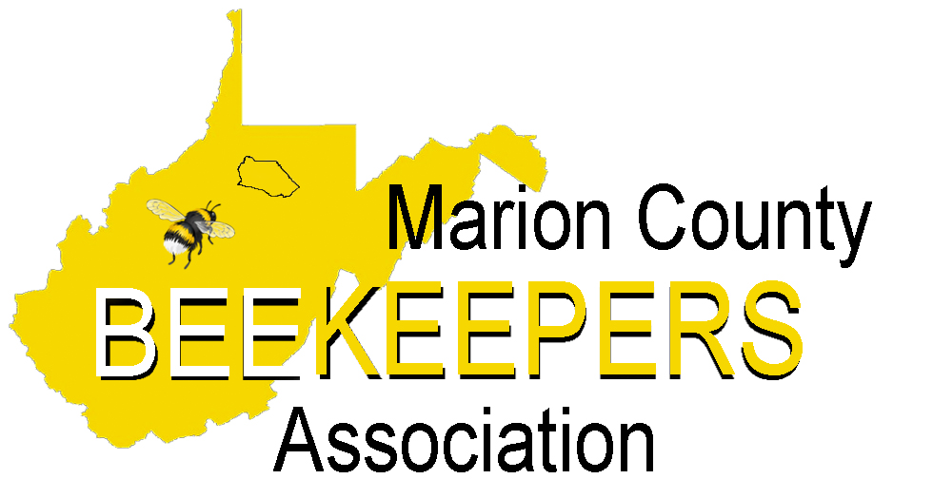

Check out our newly designed, user-friendly website: mcbawv.com and visit us on Facebook at Marion County Beekeepers

Message From the President
Happy New Year Keeper of the Bees.
I hope all is well your way and with the bees. This Fall and Winter have been mild to warm and that means the bees use more stores. So go out and check them. You don’t have to open them up but give them a heave-ho, lifting one side. If it feels like a box of rocks, great. If it is light, you gotta feed them, dry sugar under the inner cover.
If you need help, just ask. We’re all in this together.
It’s time to check your equipment. Most bee suppliers are running specials, save money.
Hope to see you at the monthly meetings and hear some great bee stories.
Charlie Chipps
MCBA President

2022 MARION COUNTY BEEKEEPERS ASSOCIATION OFFICERS
President
Charlie Chipps (304) 612-5478 (cwchipps@msn.com)
Vice President
Louisa Householder (304) 844-0236 (theweezie@msn.com)
Secretary
Joni Morris (304) 841-1510 (alphaapiarieswv@yahoo.com)
Treasurer
Amy Kaiser (304) 368-0609 (ottoamy105@yahoo.com)
Chaplain
Otto Kaiser (304) 368-0609 (ottoamy105@yahoo.com
Webmaster
Dana Gray, Webmaster (304) 694-1968 (wvabeek@gmail.com)
Newsletter Editor
Nancy Postlethwait (304) 366-9938 (lpostlethwait@aol.com)
Board of Directors
Chuck Cienawski (304) 534-3196 (ccienawski1017@aol.com)
Bill Daetwyler (304) 476-6218
Tyler Poling (304) 677-5333 (tylerpoling2011@gmail.com)

MCBA Committees
Phone. Contact Amy Kaiser if you have a change of phone number or email address.
Mentors Coordinator. Louisa Householder
Library. All types of media are available at monthly meetings.
Association of the Year Application.

WVBA Executive Board: Louisa Householder, President; Chuck Cienawski is the Marion Co. Representative; Otto Kaiser, Alternate; Aretha Kees, WVBA photographer and historian; Nancy Postlethwait, Budget and Finance Chairwoman.

WVDA State Apiarist: Shanda King (304-840-3236) sking@wvda.us

Association of the Year - Marion County has won this award many times due to our participation in activities and education events. If you give public presentations, be sure to report it.

Judy Wilhelm Youth Scholarship - MCBA offers the Judy Wilhelm Youth Beekeeping Scholarship. Marion and Taylor County students between 12 and 17 are invited to apply for the award. Successful recipient will receive training and equipment with a value of over $400. Our goal is to educate our youth in the skill of beekeeping and encourage a better understanding of the value of the honeybee to our environmental and to the food chain. Information and the application can be found on mcbawv.com.

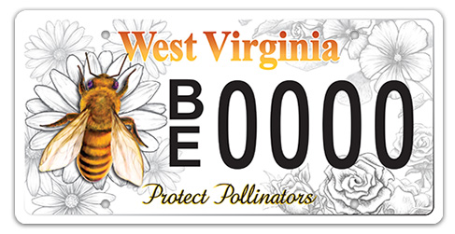
The WV DMV has issued a new license plate to promote pollinator awareness. It is now available at local DMV offices or online at https://transportation.wv.gov/DMV/DMVFormSearch/DMV-46-TR-wf.pdf

Bee School will be held on February 1, 3, 8, 10, 15 and the 17th at 6:00 pm. The cost will be $50. Registration forms are available online at mcbawv.c.om and can be paid through PayPal. Contact Nancy at 304-612-9699 for information and preregistration.

Registration Fee includes (non-refundable):
~Textbook and all class materials
~2022 Membership in both MCBA and WVBA
~Newsletters from both organizations
~Discount on American Bee Journal magazine
~Free registration to WVBA Conference Fall 2022

Hive Registration - WV beekeepers are required to register their hives with the WV Department of Agriculture within 10 days of the date that they are acquired. WV Code 19-13-4 states that “All apiary certificates of registration expire on June 30 of each year and must be renewed annually.” Just go to wvbeekeepers.org and then click on documents. Then go down to the section that reads WV Immunity Law and Honeybee Best Practices and click on the shield below that to find the Immunity Law and Best Practices.
West Virginia was the first state to pass the Limits of Liability Law if beekeepers sign a voluntary agreement to follow the WVDA Best Management Practices.

Mentors List – Volunteers who have offered to help if you have questions or concerns.
Chuck Cienawski (Fairmont) 304-534-3196 Louisa Householder (Bridgeport) 304-844-0236
Amy & Otto Kaiser (Barrackville) 304-368-0609 Lisa & Barry Knicely (Rivesville) 304-290-9983
Bill Daetwyler (Boothsville) 304-476-6218 Nancy Postlethwait (Meadowdale) 304-366-9938
Dana Gray (Pleasant Valley) 304-694-1968 Charlie Chipps (Whitehall) 304-612-5478

Library- Available to all MCBA members as a resource of information is the club library. MCBA has worked hard to expand the number of resources available to our club members and have approximately 70 different items that range from various Beekeeping Books to informative Beekeeping DVDs. A complete list of all materials available is on the mcbawv.com website, just click on the Library link. The size of the club’s library is quite impressive in comparison to resources available at local public libraries. Resources have typically been available at each in-person meeting. A list of these resources can be found on the Marion County Beekeepers Association Facebook page under the files folder.
If any club member would like to donate materials to the library, please feel free to contact any of the officers or board members. Or if you are aware of a newly published item or have an item you highly recommend as a valuable resource to our library, let us know. Any requests for additional items will be presented to the board for review.

Extracting Equipment for Rent—MCBA has extracting equipment for rent, including uncapping knife and tank. The cost is $25 deposit with a $15 refund when returned clean, within a 5-day period. A late fee may occur if returned late. Contact any officer or board member.

WV Market Bulletin - has a special section “Apiary Sales” for beekeepers. If you don’t already get the WV Market Bulletin, you may request it by writing to: The Market Bulletin, WV Dept. of Agriculture, 1900 Kanawha Blvd., E., Charleston, WV 25305, OR you may receive it through email by contacting: marketbulletin@ag.state.wv.us

“Telling the Bees” – Obituaries

Gerald “Jerry” Winter, 83, passed away June 30, 2021. He was a student of the 2008 Beekeeping Short Course and had been an active member ever since. He was always helpful to any beekeeper who asked for his assistance.
We extend our sympathy to his family and friends.

Toby Kisner, 45, passed away October 28, 2021. He was a student in the January 2018 MCBA Beginning Beekeeping course and was an enthusiastic learner. He attended several MCBA meetings, always arriving early to lend a helping hand. We extend our sympathy to his family and friends.

**********************************************************************************************
West Virginia Beekeepers Association News from President Louisa Householder
MCBA is an affiliated club of the WV Beekeepers Association. When you pay your $15 club dues, a portion of those dues ($6) pays for your membership to the state association. The WVBA board meets the first Saturday of February, June, and November. If you have any comments, suggestions or concerns that you would like to offer the state association, contact our association representative Chuck Cienawski.

Check out our WV Beekeepers website www.wvbeekeepers.org and visit us on FB

WVBA is offering two conferences in 2022 that are right here in Monongahela and Marion counties March 18-19 and September 9-10. If you have never attended a conference before, you won't want to miss this year. Conferences are full of education opportunities, bee chat, and bee supplies right here in our backyard. The WVBA Winter Speaker series is back! Join us each of the dates below at 7:00 PM EST for an hour to glean a variety of beekeeping tips from our very own WV beekeepers. We will use the Zoom platform again this year. The program is provided free of charge to current members. Registration information will be sent for each presentation by email. You can join the meeting by computer or call to listen in with your phone. Any questions or suggestions about the program can be sent to wvbapresident@gmail.com .
January 11th – Preparing Your Spring Garden for Pollinators – Kristen Wickert, PhD, Lead Pollinator Scientist, Appalachian Headwaters Native Plant & Environmental Education Program
February 8th - WV Conservation Agency – New programs in urban farming for beekeepers. Sigrid Teets, Conservation Specialist with Monongahela Conservation District
February 23rd – Save the Pollinators- presented by WVBA Save the Pollinator committee
March 8th – Swarm Removal Procedures – Sean Phelps, Certified Level Master Beekeeper
April 5 – All About Cut-outs - Justin King, WVBA Treasurer, President of Mountaineer Beekeepers Association.
May - TBD
*******************************************************************************************
We would like to recognize Resa Smith for her special support of MCBA. Resa has been utilizing Facebook’s birthday fundraiser feature for the past few years to garner financial support for MCBA. She has generated several hundred dollars in donations, which is very much appreciated. Thanks Resa!!!
Editor’s Note: We are hoping to hold in-person meetings this year. Get your dues in early so you won’t miss the programs that we have set up for the year.
I know a lot of you have lost hives this year but please don’t be discouraged. I know it can be an expensive hobby but the honeybee is very important to our environment and food supplies.
If you know someone who might be interested in beekeeping, invite them to take our beekeeping class and encourage them to join our group and attend monthly meetings.
Hoping to see all of you soon. And hopefully a lot of new faces.
Nancy

***** MCBA 2022 Program Schedule ****

January 13th, Thursday 6-8 PM Annual dues collection at 6:00. Please fill out and bring the enclosed registration form.
Eldora United Methodist Church At 7:00 information on nucs, packages, and queens and a presentation on Late Winter Feeding.

February 1 to 17^{th,} 6-8 PM Beginning Beekeepers Short Course– More information available on website

Eldora United Methodist Church mcbawv.com and Marion County Beekeepers – Fairmont Facebook page

Feb. 24 - Thursday, 7-9 PM Spring Planning Shanda King
Eldora United Methodist Church WV State Apiarist

March 18th & 19th Spring Conference Hosted by Monongalia County Beekeepers Association
WVU Evansdale Campus – Towers https://moncountybeekeepers.org/wvba-spring-conference for more info.

March 24 - Thursday, 7-9 PM Splitting, Inspecting and Feeding Bill Daetwyler
Eldora United Methodist Church Gearing Up for the Honey Flow

April 28 - Thursday, 7-9 PM Making Queens Joni Morris, Charlie Chipps
Eldora United Methodist Church Louisa Householder

May 7 – Sat., 10-2 (Rain Date May 21) Field Day – Looking into the Hive Shanda King
Louisa Householder Bee Yard Doors Prizes WV State Apiarist

June 23 – Thursday, 7-9 PM Mite Treatments for Top Bar Hive Dana Gray
Eldora United Methodist Church

July 28 - Thursday, 6:00 PM- ?? Picnic – Covered Dish
East Marion Pavilion Meat, Drinks and dinnerware will be provided by MCBA

August 25 – Thursday, 7-9 PM Fall Management Charlie Chipps
Eldora United Methodist Church

Sept 9&10 WVBA Fall Conference Key Speaker will be Kamon Reynolds
Robert Mollohan Center – Fairmont Email will be sent out to all members or you can check it out at wvbeekeepers.org

Sept 22– Thursday, 7-9 PM Uses for Beeswax Dana Gray
Eldora United Methodist Church

Oct. 27 - Thursday, 6:00 PM Harvest Covered Dish Dinner
Eldora United Methodist Church Meat, drinks and dinnerware provided. Directions at bottom of page.

Directions:

Eldora United Methodist Church – Sapps Run Road. Rt 73 South of Mall – past Industrial Park road – round the sharp turn and next left. Signs are visible from the road.

East Marion Park – Just off the Gateway – Or from I-79 exit 136. Large pavilion just across from the entry to Wave-Tek pool.

Directions to Louisa Householer’s Bee yard will be given at a later date.

DUES. We are now offering an alternate method to pay membership dues. If you would like to pay using PayPal, check it out on our website. Click on the Membership link and follow the instructions there.

OR.. If you prefer to pay by check, fill out the form below and mail it to Amy, or just bring it to the January Meeting.
2022
Marion County Beekeepers Association (MCBA)
Membership Form

Marion County & State Dues --- $15 per calendar year (Jan.1-Dec.31)
Includes Membership in both the Marion County and the WV Beekeepers Associations, two WVBA newsletters and one MCBA newsletter and a subscription discount for American Bee Journal magazine.

PLEASE PRINT CLEARLY AND INCLUDE ALL INFORMATION

Name(s) to appear on membership card (may include immediate family names, if desired)

___________________________________________________________________________________

___________________________________________________________________________________

Address____________________________________________________________________________

City, State, Zip _____________________________________________________________________

Best Contact Phone Number(s) __________________________________________________

E-mail Address _______________________________________________________________

Cell Phone # (If you wish to receive reminders of meetings or other events)_________________

Number of years as a Beekeeper ___________ Present Number of Hives ________________
~~~~~~~~~~~~~~~~~~~~~~~~~~~~~~~~~~~~~~~~~~~~~~~~~~~~~~~~~~~~~~~~~~~~~~~~~~~~~~~~

West Virginia State Law requires beekeepers to register their hives annually with the West Virginia Department of Agriculture. This helps to maintain information on the beekeeping industry in the state. Failure to register your hives will prevent you from being considered for any aid that might become available. All apiary certificates of registration expire on June 30 of each year.

____ I agree to register my hive(s) and will mail the application to the WVDA.
~~~~~~~~~~~~~~~~~~~~~~~~~~~~~~~~~~~~~~~~~~~~~~~~~~~~~~~~~~~~~~~~~~~~~~~~~~~~~~~~
I am willing to have my information included in a directory of MCBA members that will be made available to MCBA club members to improve communication and information sharing.
YES NO (circle one)
~~~~~~~~~~~~~~~~~~~~~~~~~~~~~~~~~~~~~~~~~~~~~~~~~~~~~~~~~~~~~~~~~~~~~~~~~~~~~~~~
Please return this form:
(at your next monthly club meeting or via US Mail) to:
Marion County Beekeepers Association (MCBA)
P O Box 303
Kingmont WV 26578
Make checks payable to MCBA

